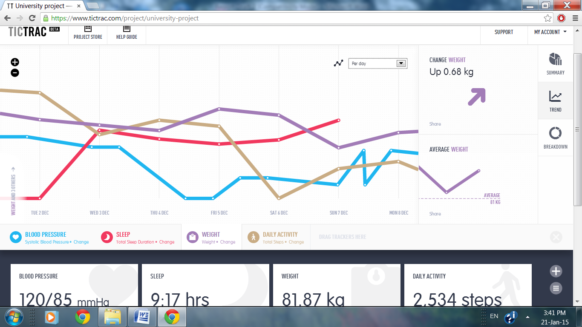
Fig. 2. Screenshot of combined biometric data trends in Tictrac

